**Dash Homework**

**Deadline**: 09 May 2024

**Grading:** 2.5 points

**Description:**

The goal of this homework is to create interactive charts for the dataset provided (data about mice). The codes for the first chart are provided. You need to create 3 additional charts as in the screenshot below. You can find the requirements below as well as the final result that you need to get.  
  
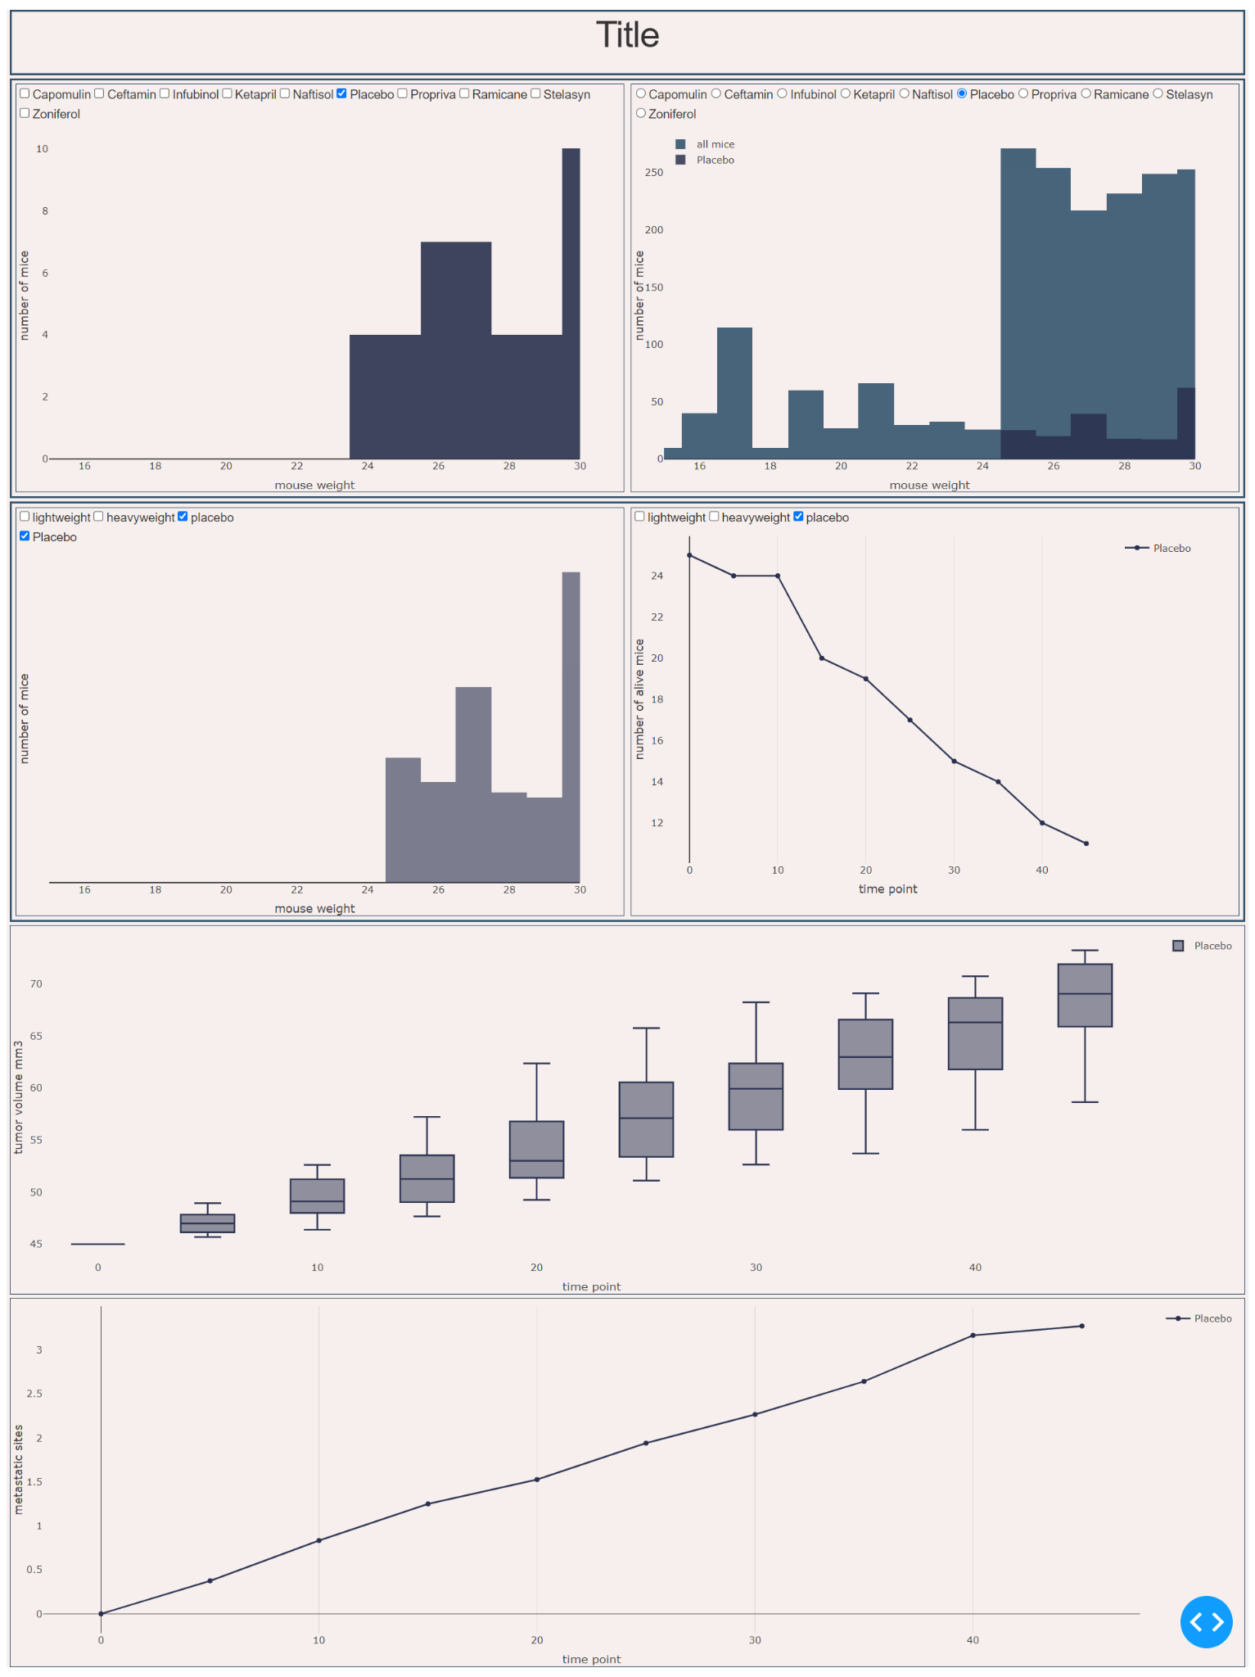

**Chart 2**

Chart 2 describes the weight distribution of different drug types copmared to the overall weight distribution. We have *mouse weight* in X axis and *the number of mice* in Y axis. So any given graph show the weight distribution for the selected drug type versus all the drugs. So, for example, for placebo there are ?? mice with a weight of 25.

**Inputs:** the type of drugs.

**Chart 3**

Chart 3 is the survival function for all drugs. We have *mouse weight* in X axis and *the number of mice* in the Y axis. So, for example, for placebo drugged mice having weight of 30 is more common than any other weight.

**Inputs:** the group of drugs. We have the same groups as for the 4th chart: *lightweight*, *heavyweight* and *placebo*. When you click, for example, on *lightweight*, all the lines for that group of drugs (*Ramicane, Capomulin*) should appear.

**Chart 4**

Chart 4 is the survival function for all drugs. We have *time* in X axis and *the number of mice alive* in the Y axis. So, for example, for placebo on the 30th day only 15 mice were alive.

**Inputs:** the group of drugs. We have the same groups as for the 3rd chart: *lightweight*, *heavyweight* and *placebo*. When you click, for example, on *lightweight*, all the lines for that group of drugs (*Ramicane, Capomulin*) should appear.

See the screenshots below:

**Case 1: Nothing is selected**

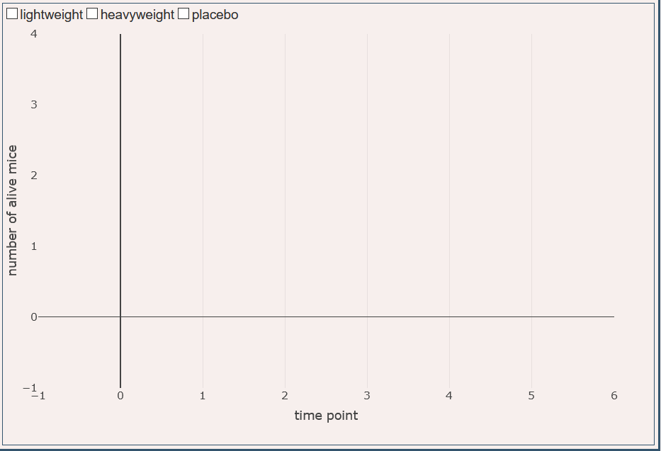

**Case 2: Only placebo is selected**

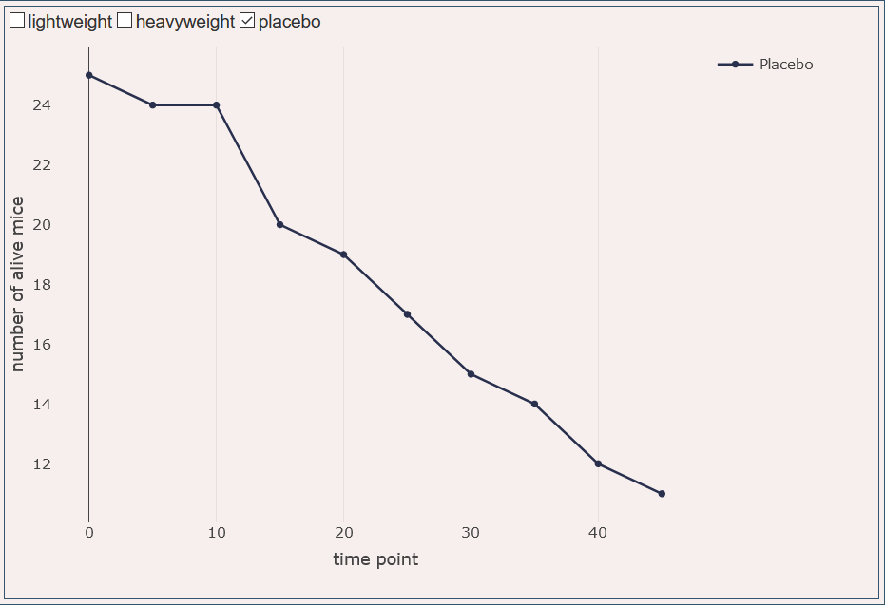

**Case 3: Everything is selected**

